**NAME : VIJAYKUMAR**

**DATA ANALYTICS SQL- MINI PROJECT**

**Insight no 1**

To read the whole table

select * from cars24;

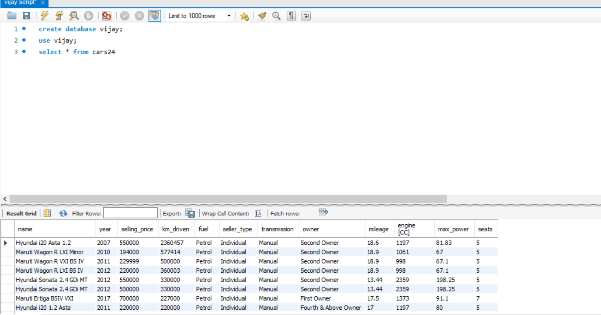

**Insight no 2**

To count all from table

select count(*) from cars24;

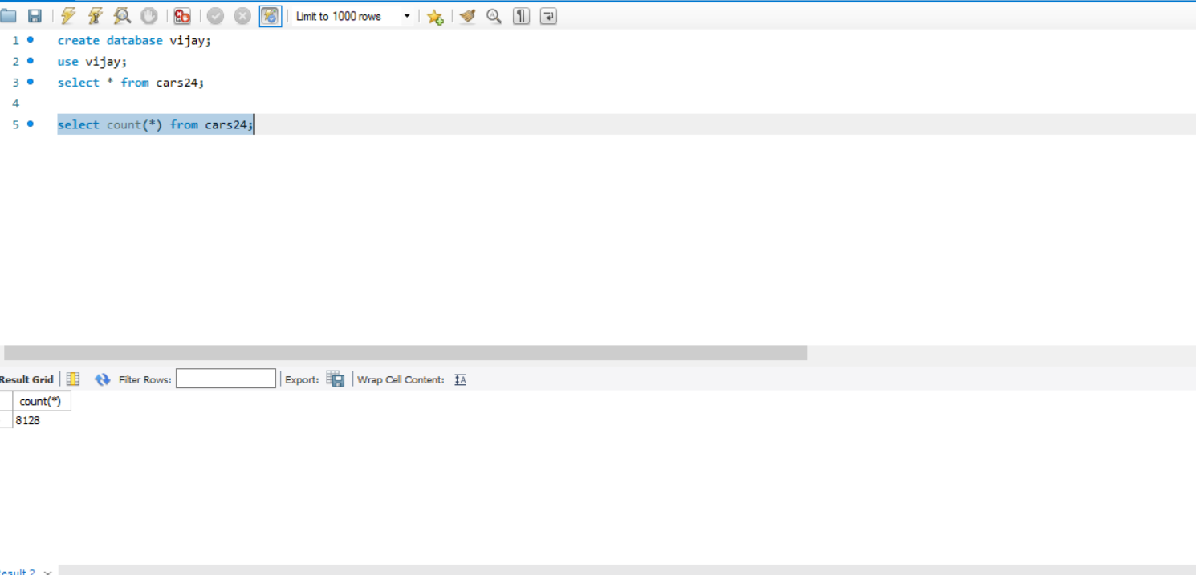

**Insight no 3**

To find the all details of the car in the year 2007

select * from cars24

where year = 2007;

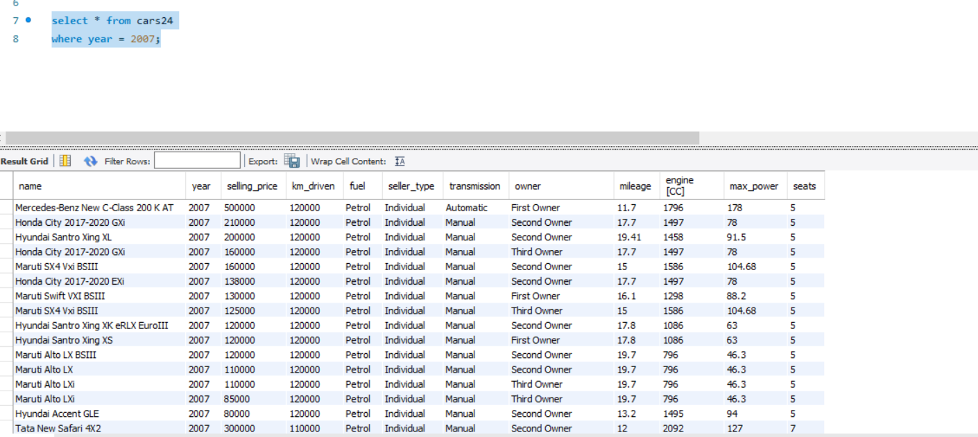

**Insight No 4**

To find the all details of the table in the year 2007 and selling price greater than 10000

select * from cars24

where year = 2010 and selling_price >10000;

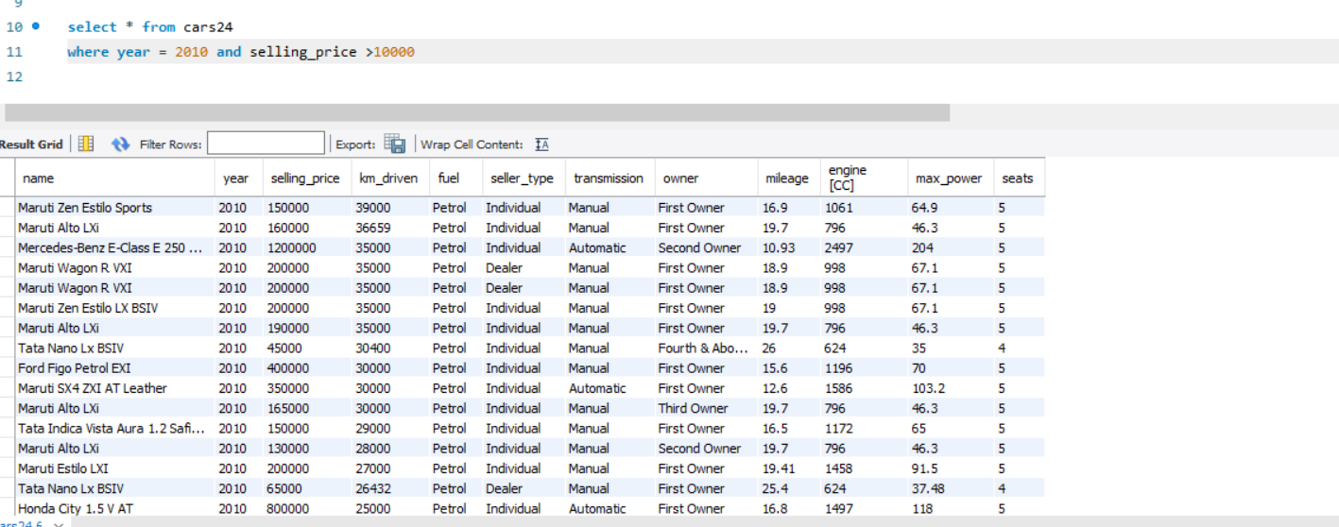

**Insight No 5**

To find the all details of the table and order them in ascending order of the year

select * from cars24

order by year asc;

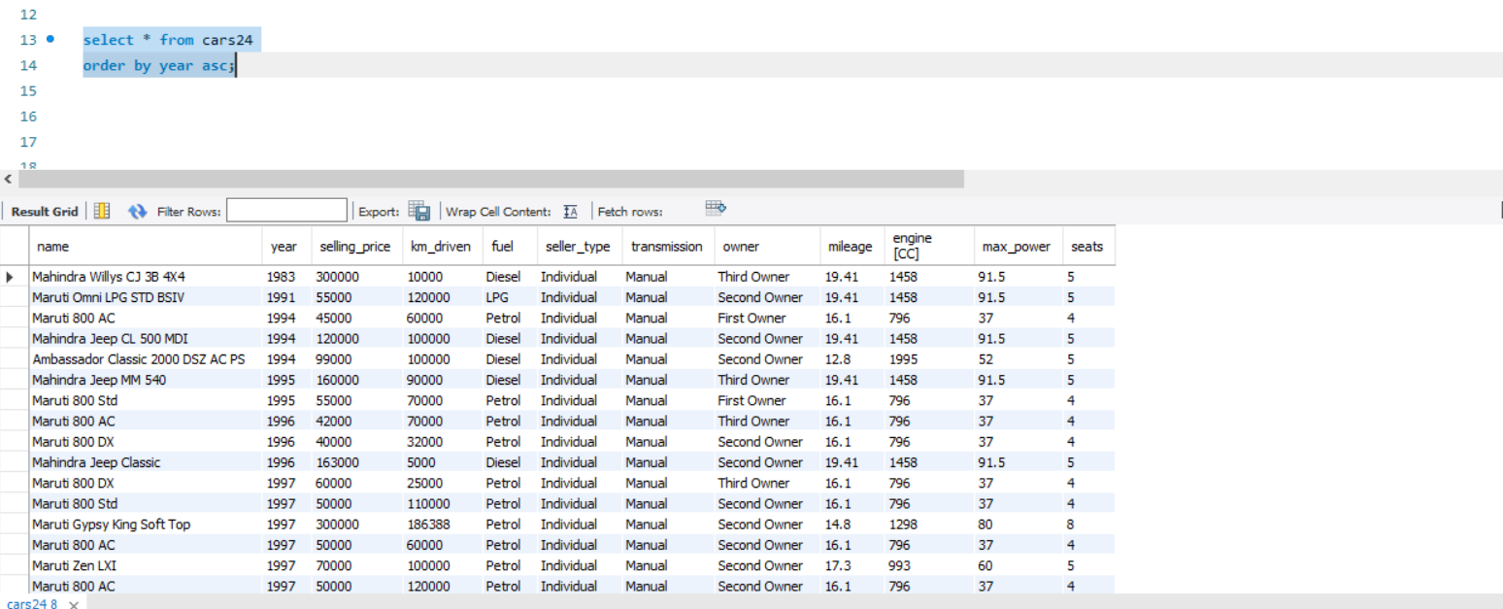

**Insight No 6**

To find the details of the table that starts with the name Hyundai

select * from cars24

where name like ('Hyundai%');

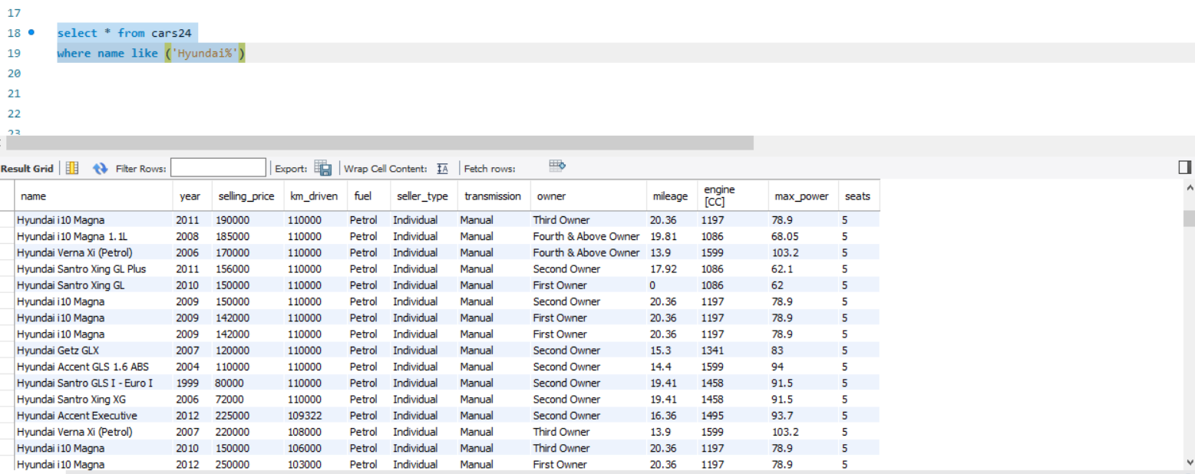

**Insight No 7**

To find the details of the table where the year ends with number 2

select * from cars24

where year like ('___2');

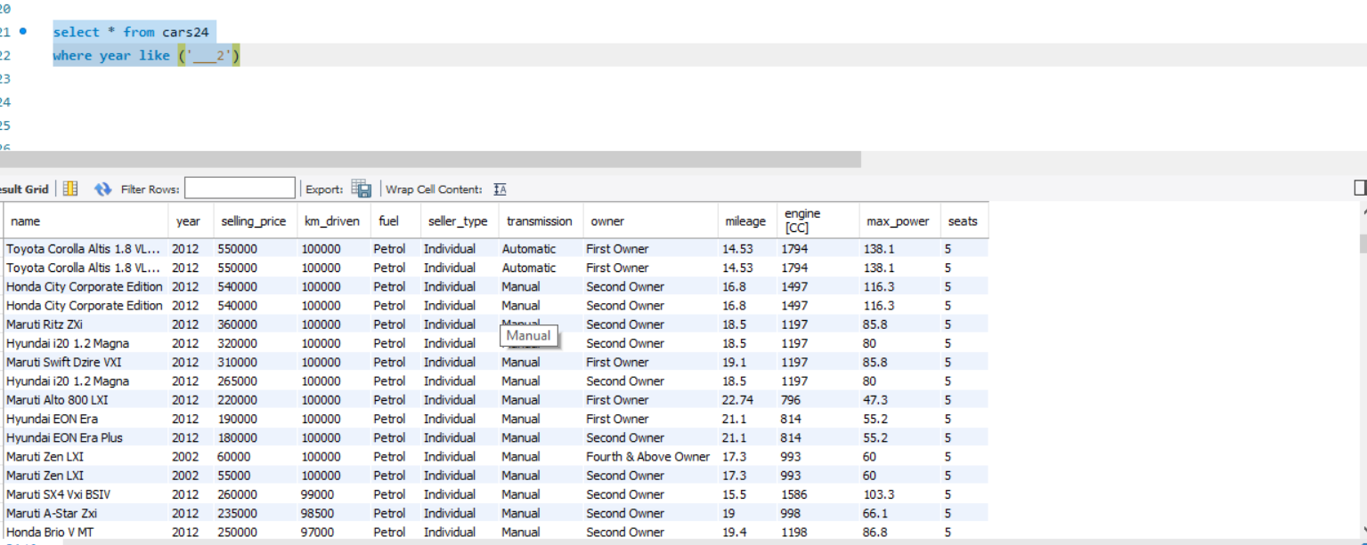

**Insight No 8**

To update the details of the table by changing diesel in the place of petrol

update cars24

set fuel = 'diesel'

where fuel = 'petrol';

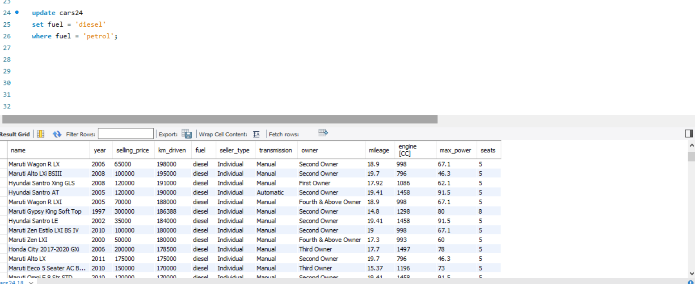

**Insight No 9**

To count the total no of petrol using cars from the table

select count(*) from cars24

where fuel = 'petrol';

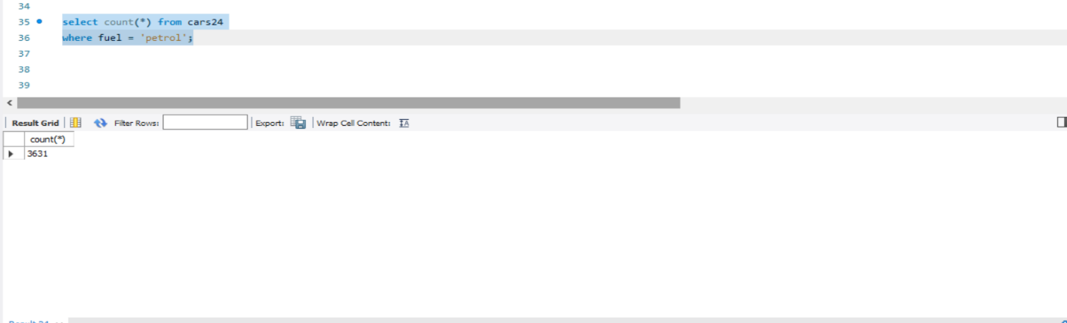

**Insight No 10**

To find the average selling price

Select avg(selling_price) from cars24 as avg_sellingprice;

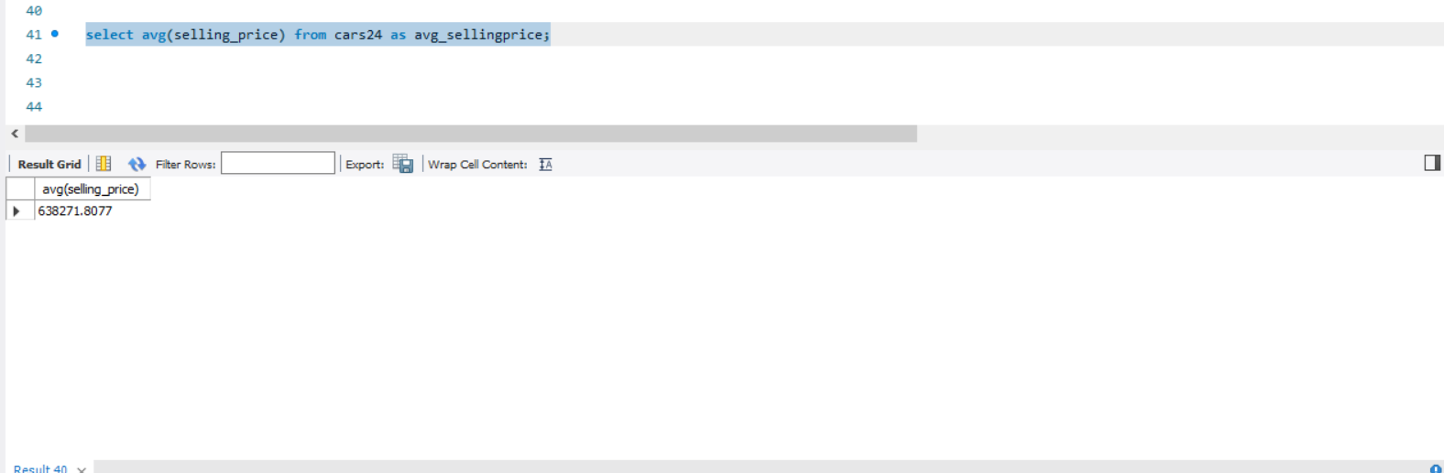

**Insight No 11**

To find the maximum selling price

Select max(selling_price) from cars24 as max_sellingprice;

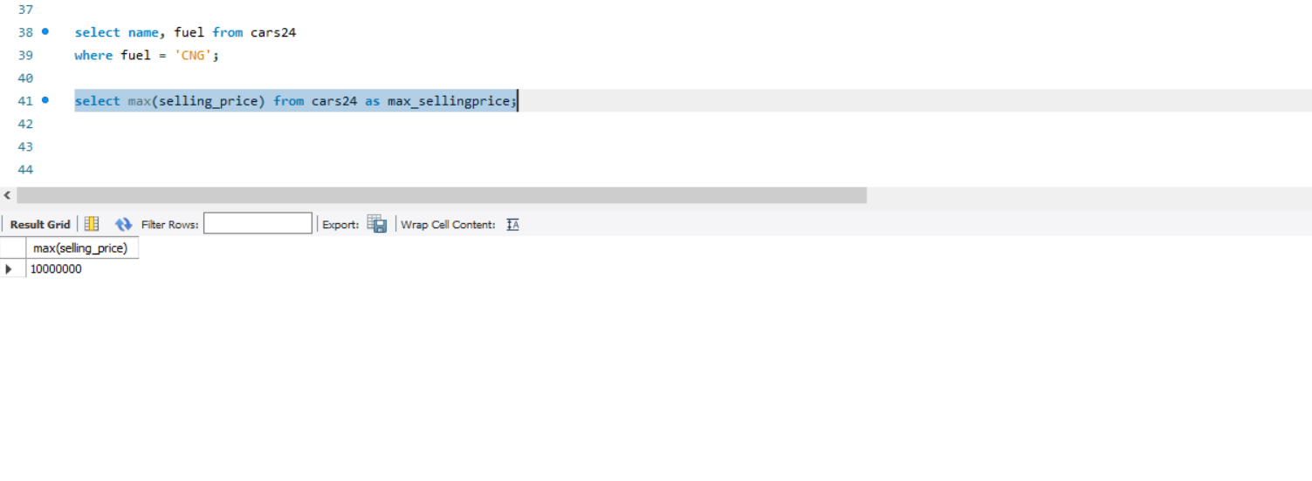

**Insight No 12**

To find the minimum selling price

Select min(selling_price) from cars24 as min_sellingprice;

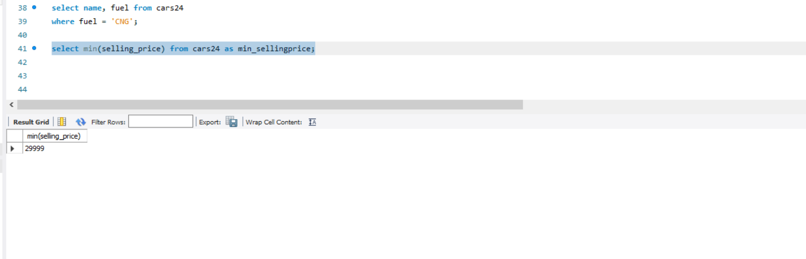

**Insight No 13**

To find the total selling price

Select sum(selling_price) from cars24 as total_sellingprice;

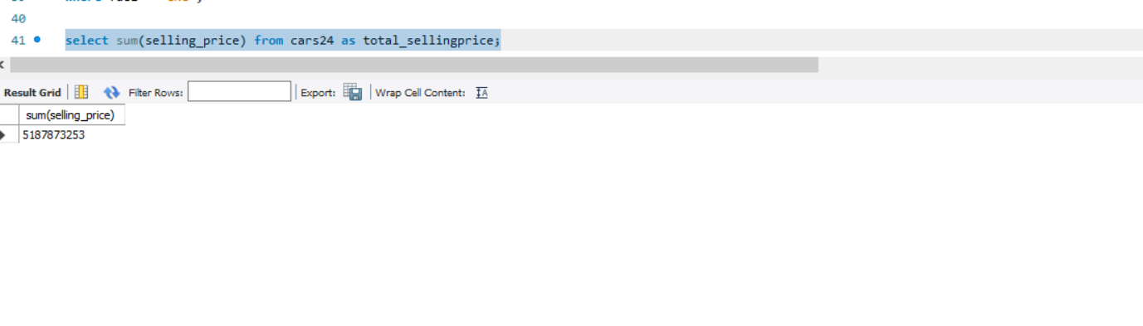

**Insight No 14**

To find the unique type of transmission

select distinct transmission from cars24;

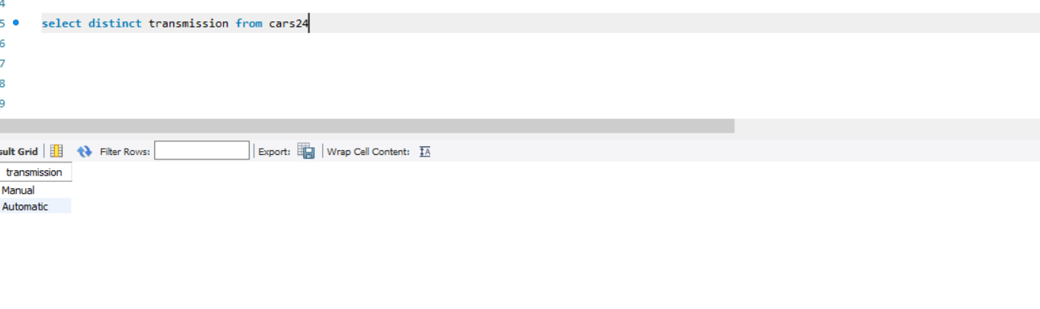

**Insight No 15**

To find the max kilometer driven

select max(km_driven) from cars24 as max_kmdriven;

select * from cars24

where km_driven = (select max(km_driven) from cars24 as max_kmdriven);

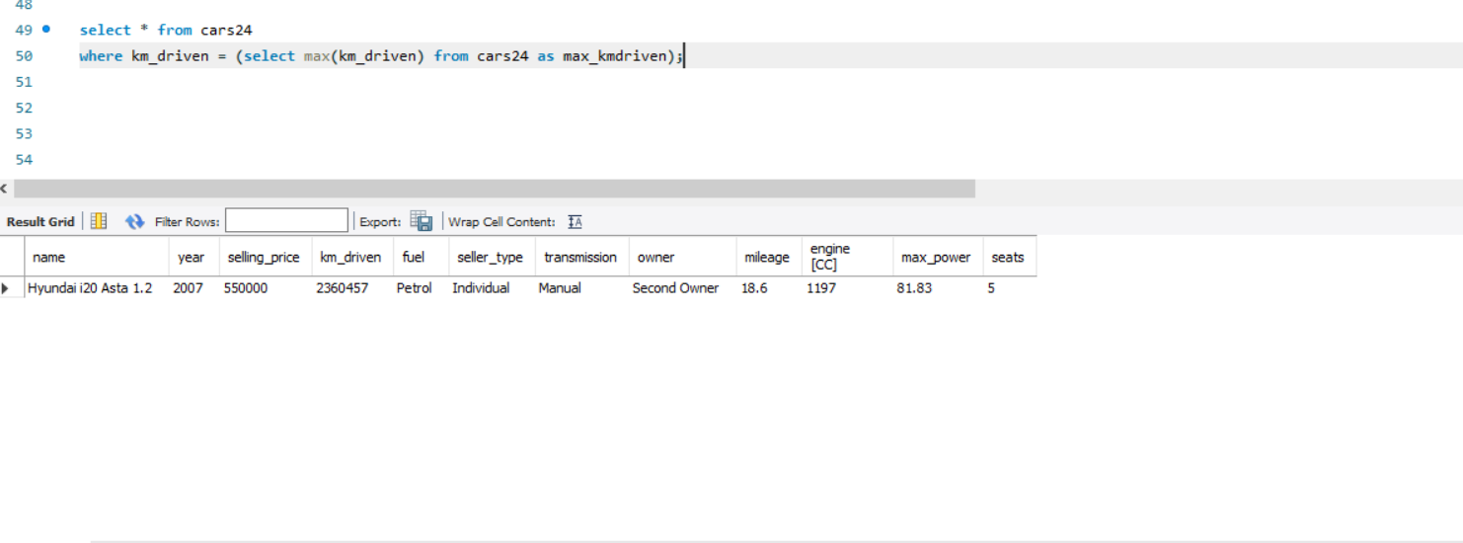

**Insight No 16**

To find the next max kilometer driven

select max(km_driven) from cars24

where Km_driven < (select max(km_driven) from cars24 as max_kmdriven);

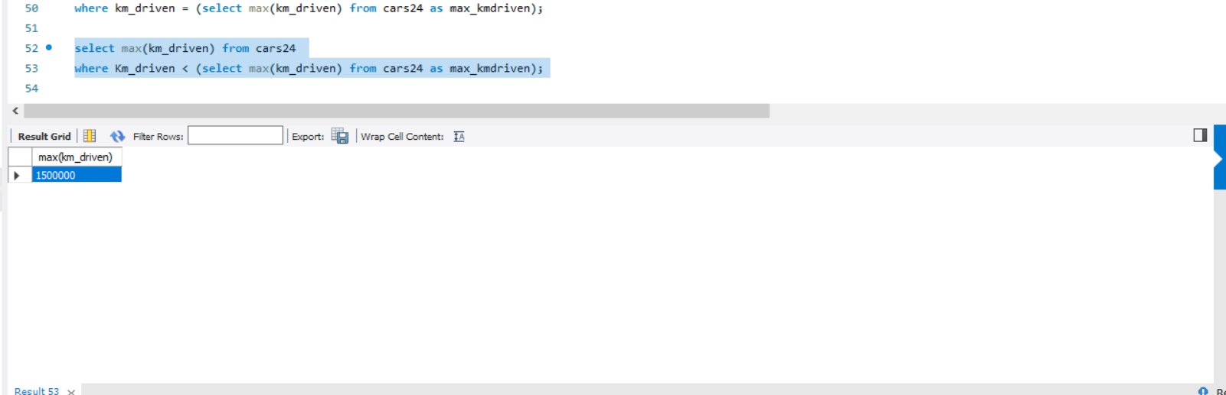

**Insight No 17**

To find the max selling price , group by selling price , order by descending.

select max(selling_price) from cars24

group by selling_price

order by selling_price desc

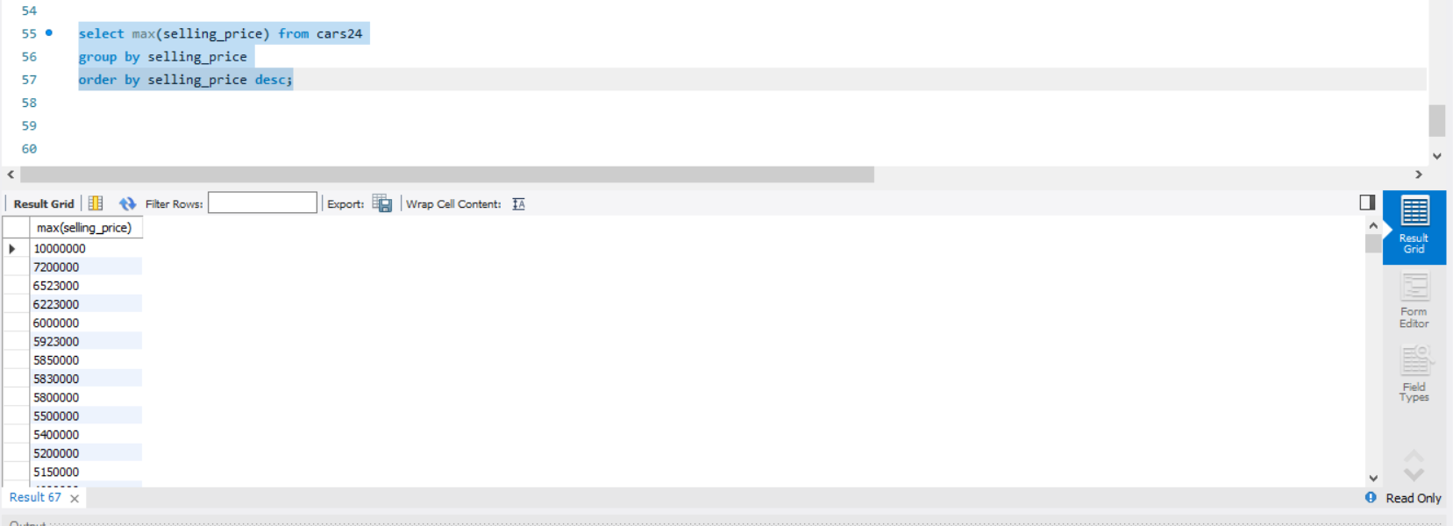

**Insight No 18**

To find the first 10 max selling price , group by selling price , order by descending.

select max(selling_price) from cars24

group by selling_price

order by selling_price desc

limit 10;

